**Assignment 05**

***Place your code below each question***

The following list reflects the current data requests from city managers. Provide the SQL statements that satisfy the requests. Test the statements and show execution results.

1. List all criminals along with the crime charges filed. The report needs to include the criminal ID, name, crime code, and fine amount.

USE CityJailSummerDB

SELECT criminals.criminal_id, [first], [last], crime_code, fine_amount FROM criminals, crimes, crime_charges

WHERE criminals.criminal_id = crimes.criminal_id AND crimes.crime_id = crime_charges.crime_id

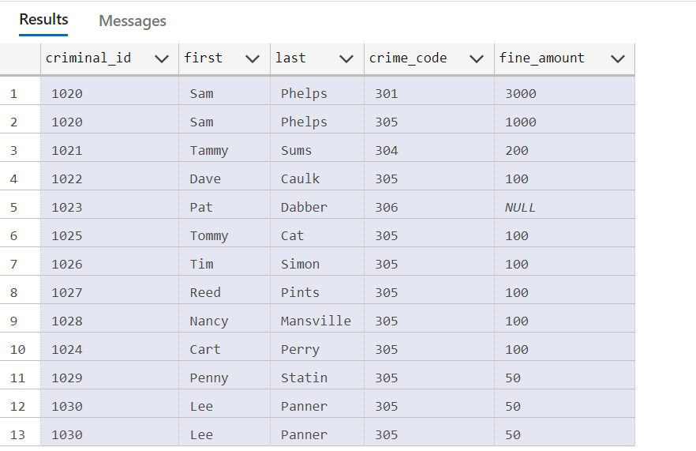

1. List all criminals along with crime status and appeal status (if applicable). The reports need to include the criminal ID, name, crime classification, date charged, appeal filing date, and appeal status. Show all criminals, regardless of whether they have filed an appeal.

USE CityJailSummerDB

SELECT criminals.criminal_id, [last], [first], classification, date_charged, filing_date, appeals.[status]

FROM criminals, crimes, appeals

WHERE criminals.criminal_id = crimes.criminal_id AND crimes.crime_id = appeals.crime_id

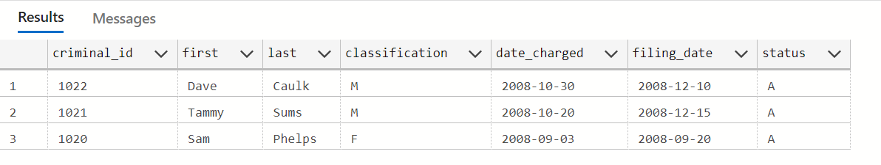

1. List all criminals along with crime information. The report needs to include the criminal ID, name, crime classification, date charged, crime code, and fine amount. Include only crimes classified as “Other.” Sort the list by criminal ID and date charged.

USE CityJailSummerDB

SELECT criminals.criminal_id, [first], [last], classification, date_charged, crime_code, fine_amount  FROM criminals, crimes, crime_charges

WHERE criminals.criminal_id = crimes.criminal_id AND crime_charges.crime_id = crimes.crime_id AND classification = 'O'

ORDER BY criminal_id

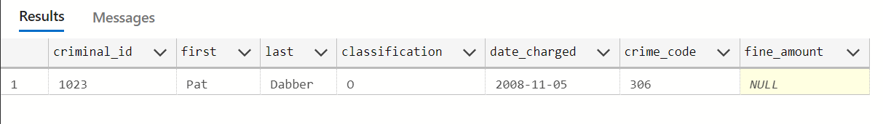

USE CityJailSummerDB

SELECT criminals.criminal_id, [first], [last], classification, date_charged, crime_code, fine_amount  FROM criminals, crimes, crime_charges

WHERE criminals.criminal_id = crimes.criminal_id AND crime_charges.crime_id = crimes.crime_id AND classification = 'O'

ORDER BY date_charged



1. Create an alphabetical list of all criminals, including criminal ID, name, violent offender status, parole status, and any known aliases.

USE CityJailSummerDB

SELECT criminals.criminal_id, [first], [last], v_status, p_status, alias

FROM criminals LEFT JOIN aliases ON criminals.criminal_id = aliases.criminal_id

ORDER BY LAST

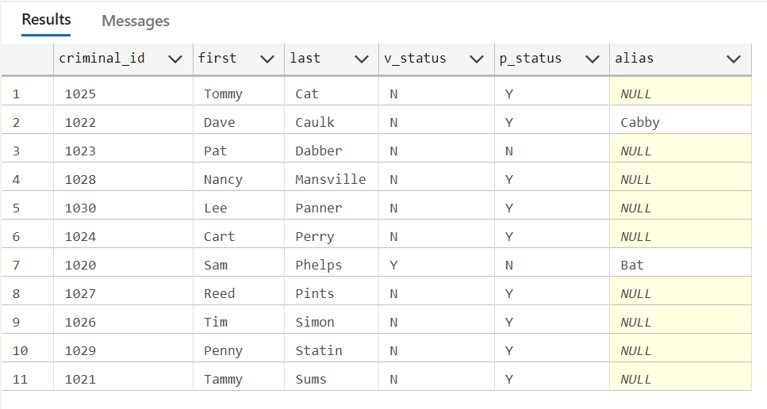

1. A table named Prob_Contact contains the required frequency of contact with a probation officer, based on the length of the probation period (the number of days assigned to probation). Review the data in this table, which indicates ranges for the number of days and applicable contact frequencies. Create a list containing the name of each criminal who has been assigned a probation period, which is indicated by the sentence type. The list should contain the criminal name, probation start date, probation end date, and required frequency of contact. Sort the list by criminal name and probation start date.

USE CityJailSummerDB

SELECT [first], [last], start_date, end_date, con_freq

FROM criminals JOIN sentences ON criminals.criminal_id = sentences.criminal_id

JOIN prob_contact ON DATEDIFF (day, sentences.start_date, sentences.end_date) BETWEEN prob_contact.low_amt AND prob_contact.high_amt

WHERE sentences.[type] = 'P'

ORDER BY [last]

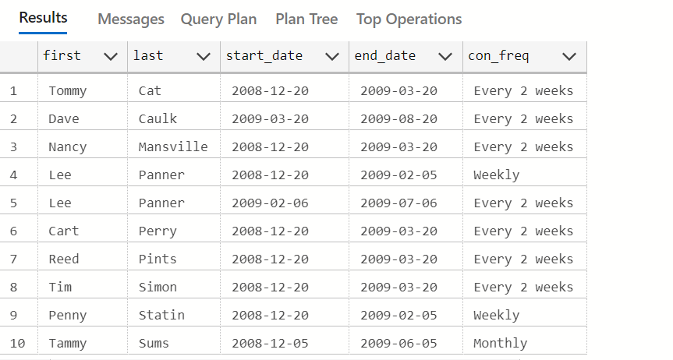

USE CityJailSummerDB

SELECT [first], [last], start_date, end_date, con_freq

FROM criminals JOIN sentences ON criminals.criminal_id = sentences.criminal_id

JOIN prob_contact ON DATEDIFF (day, sentences.start_date, sentences.end_date) BETWEEN prob_contact.low_amt AND prob_contact.high_amt

WHERE sentences.[type] = 'P'

ORDER BY [start_date]

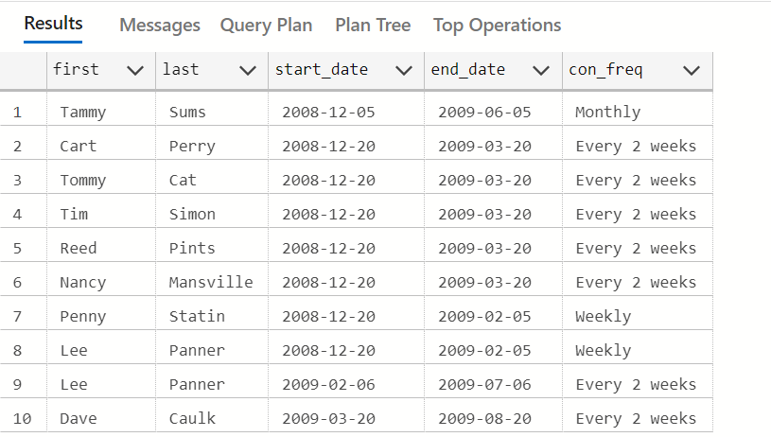

1. A column named Mgr_ID has been added to the Prob_Officers table and contains the ID number of the probation supervisor for each officer. Produce a list showing each probation officer’s name and his or her supervisor’s name. Sort the list alphabetically by probation officer name.

USE CityJailSummerDB

SELECT probation.[first], probation.[last], manager.[first], manager.[last]

FROM prob_officers probation LEFT JOIN prob_officers manager

ON probation.mgr_id = manager.prob_id

ORDER BY probation.[last]

